**GOVT. COLLEGE FOR WOMEN::HINDUPUR**

**DEPARTMENT OF COMPUTER APPLICATIONS**

**PERSONAL PROFILE**

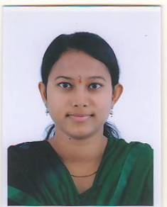

**K.J.NANDINI , M TECH[CSE]**

**Designation:** Lecturer in Computer Applications,

Govt. College for Women , Hindupur

C:\Users\NSPR\AppData\Local\Temp\ksohtml1860\wps2.pngAndhra Pradesh, India

Mobile : **9866551991**

E-mail : kj.nandini223@gmail.com,

**TEACHING EXPERIENCE**

|  |  |  |
| --- | --- | --- |
| COURSES TAUGHT | NAME OF THE COLLEGE | DURATION |
| U. G. (B.TECH) | BIT INSTITUTE OF TECHNOLOGY | 03 – 01 – 2017 TO 11/01/21 |
| U. G. (B . SC.) | N.S.P.R.GOVERNMENT DEGREE COLLEGE FOR WOMEN , HINDUPUR | 13/01/21 TO TILL DATE |

**Refresher Courses/Orientation Courses/Trainning Programmes attended:**

|  |  |  |  |
| --- | --- | --- | --- |
| SL.NO | COURSE | DATE | VENUE |
| 1 | 3 DAY TRAINING PROGRAMME ON INTERNSHIP AND LMS | 02 – 02 – 2023 TO 04 – 02 – 2023 | GOVT. COLLEGE (AUTONOMOUS) ,ANANTAPURAMU. |
| 2 | 6 DAY TRAINING OF THE TRAINERS PROGRAM (TOT)  FACULTY DEVELOPMENT PROGRAMME | 05-06-2023 TO 10-06-2023 | GOVT. COLLEGE (AUTONOMOUS) ,ANANTAPURAMU. |

**Extension work &Best Practices:**

1. Celebrated WORLD **COMPUTER LITERACY DAY** every year.
2. Arranged Guest Lectures in the college.